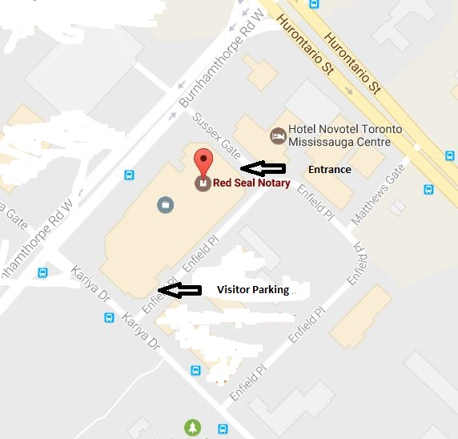

RSN Mississauga is located at 50 Burnhamthorpe Road West, Suite 401, Mississauga L5B 3C2, just south of Square One. (East Tower of the Sussex Centre).
Hours
Monday to Friday 10:00 am to 6:00 p.m.
Saturday 11:00 a.m. to 6:00 p.m.
IF YOU ARE COMING ON SATURDAY:
- The elevators are locked on Saturdays. You can ask at the security desk on the ground floor if they will let you up to the fourth floor. Otherwise, please call (647) 407-6411 and the Notary on duty will come to the lobby to get you.
- Please do not pre-sign your documents. They must be signed in front of the Notary.
- WITNESSES: We cannot provide witnesses. You must bring your own. Please check your documents carefully before coming to our office.
- Usually we can perform the required services in 10 to 15 minutes but Saturday is our busiest day and wait times may be longer than usual. It is a walk-in office with no appointments so we cannot predict wait times.

THANK YOU FOR CHOOSING RED SEAL!

